**MyOwnWebsite Mini Project**

For this I have created a main page with 4 menus. There are also 4 different components: home, about, qualifications and motivation.

Each menu click loads a different component.

These are the different pages:

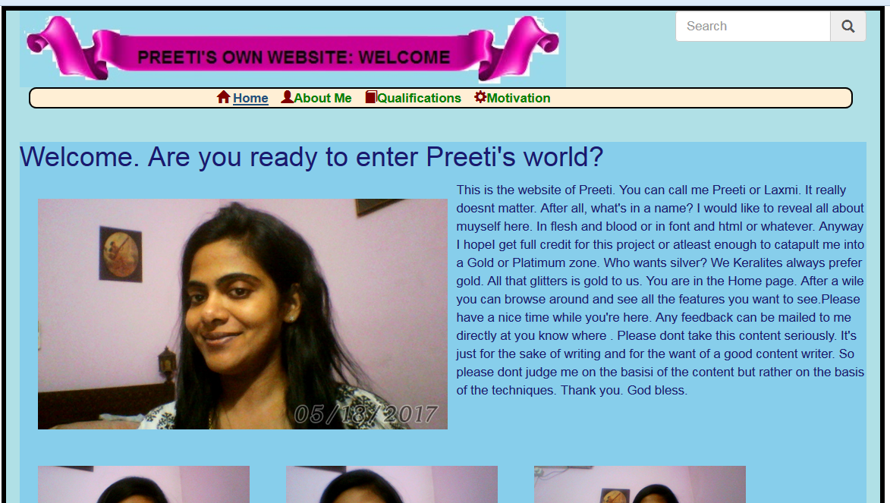

About

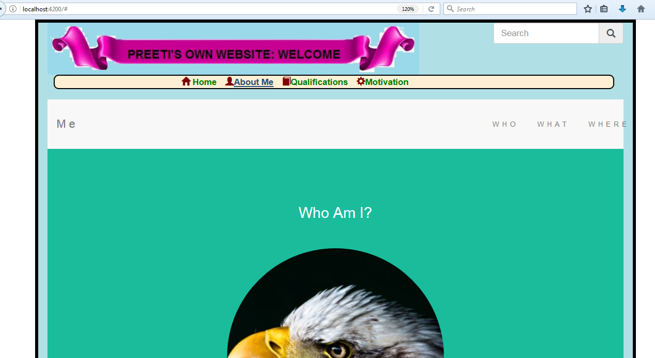

Qualifications

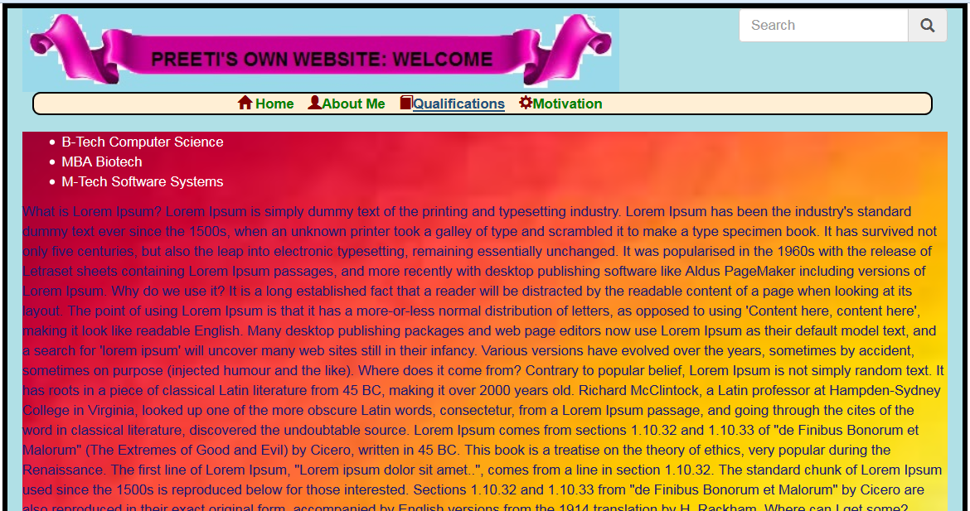

Motivation

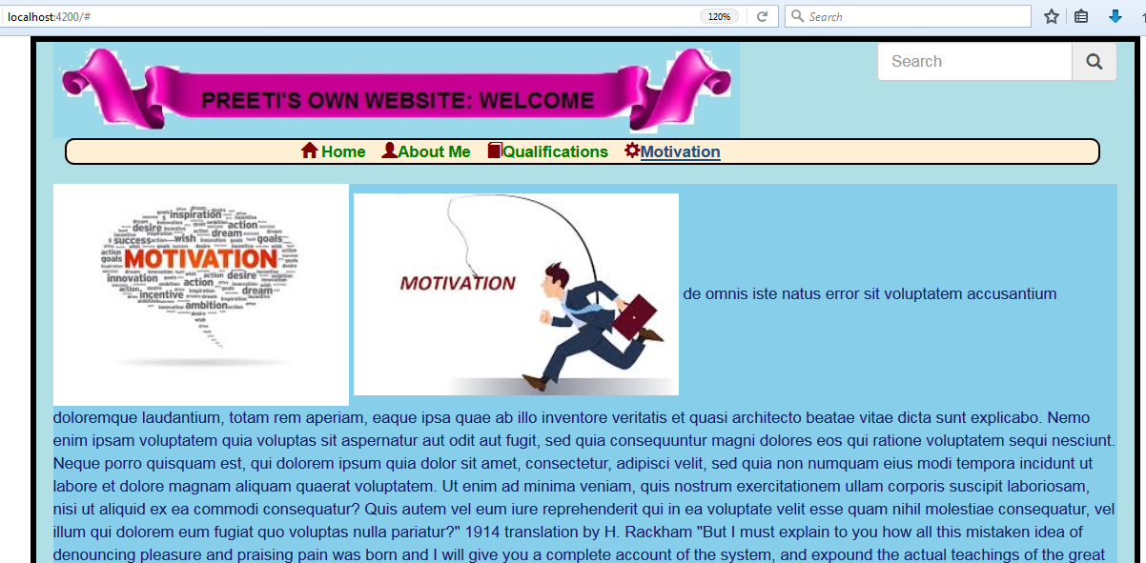

To make the front end attractive , bootstrap framework has been used.

Search box and footer are provided and images are used. Glyphicons are used.

The code is compartmentalized in each of the 4 components and the main component merely invokes the corresponding component